***Cafe Bill Generator***

*A*

*Mini Project Report*

*Submitted in partial fulfilment of the*

*Requirements for the award of the Degree of*

**BACHELOR OF ENGINEERING**

*In*

**Information Technology**

*By*

*D.Leena Reddy : 1602-20-737-020*

*J.Lithin Sai Ram : 1602-20-737-022*

*Ch.Nikithanjali : 1602-20-737-026*



**Department of Information Technology**

**Vasavi College of Engineering (Autonomous)**

**ACCREDITED BY NAAC WITH 'A++' GRADE**

**(Affiliated to Osmania University and Approved by AICTE)**

**Ibrahimbagh , Hyderabad-31 2022**

**Vasavi College of Engineering (Autonomous)**

**ACCREDITED BY NAAC WITH 'A++' GRADE**

**(Affiliated to Osmania University and Approved by AICTE)**

**Hyderabad-500 031**

**Department of Information Technology**



DECLARATION BY THE CANDIDATE

We, Leena Reddy , Lithin Sai Ram, and Nikithanjali, bearing hall ticket numbers,1602-20-737-020, 1602-20-737-022 and 1602-20-737-026, hereby declare that the project report entitled **CAFE BILL GENERATOR** is submitted in partial fulfillment of the requirement for the award of the degree of Bachelor of Engineering in Information Technology

This is a record of bonafide work carried out by us and the results embodied in this project report have not been submitted to any other university or institute for the award of any other degree or diploma.

**D. Leena Reddy**

**1602-20-737-020**

**J. Lithin Sai Ram**

**1602-20-737-022**

**Ch. Nikithanjali**

**1602-20-737-026**

**(Faculty In-Charge) (Head ,Dept of IT)**

**ACKNOWLEDGEMENT**

We extend our sincere thanks to Dr. S. V. Ramana, Principal, Vasavi College of Engineering for his encouragement.

We express our sincere gratitude to Dr. K. Ram Mohan Rao, Professor & Head, Department of Information Technology, Vasavi College of Engineering, for introducing the Mini-Project module in our curriculum, and also for his suggestions, motivation, and co-operation for the successful completion of our Mini Project.

We also want to thank and convey our gratitude towards our mini project coordinators Divya Mam and Rajyalakshmi Mam , for guiding us in understanding the process of project development & giving us timely suggestions at every phase.

We would also like to sincerely thank the project reviewers for their valuable inputs and suggestions.

Abstract

What is Cafe Bill Generator ?

As the name suggests it is a Bill Management system.

By using this Cafe Bill Management System ,you can easily Calculate the total bill of the customer .

Moreover the total bill is calculated including service charges and GST.

All you need to do is just fill the entry boxes with item quantities and click on generate bill then the program will display your total bill .

After clicking on generate bill the total bill will be displayed and user have another 2 choices

i) Save

ii) Quit

This is the customer’s choice either can save the bill or can quit from the program.

Table Of contents

**Abstract and Introduction**

The Project is Cafe Bill generator. As the name indicates it is a Bill Management system. By using this Cafe Bill Management System ,you can easily Calculate the total bill of the customer .

Moreover the total bill is calculated including service charges and GST.

All you need to do is just fill the entry boxes with item quantities and click on generate bill then the program will display your total bill .

We have a system which takes the necessary choice of the customers according to the filter  like category of the coffee.​

After clicking on generate bill the total bill will be displayed and user have another 2 choices

i) Save

ii) Quit

This is the customer’s choice either can save the bill or can quit from the program.

In this program we have used the tkinter module to create the Graphical User Interface-GUI. In this we have used Label, Text Feild, Entry Boxes and many others.

Time module to get the time at which the customer had generated the bill.​

Numpy   module to perform the various mathematical operations.​

PIL-Python Image Library we are using Image Tk and Images to Show the Coffee image on the generated Output Window.​

Random module to generate some random unique identity number to the different customers.

​

**Technology**

**Use Case Diagram**

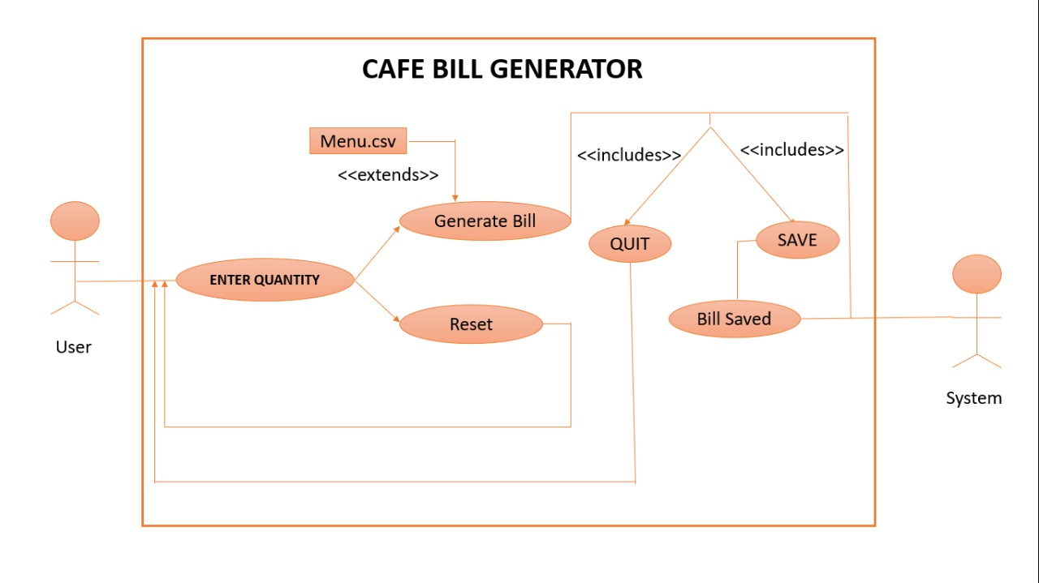

**Use Case 1**

Name: Enter Quantity

Actors: user

Description: Allow the user to enter the quantity

Precondition: none

Post-condition : none

|  |  |
| --- | --- |
| **User** | **system** |
| 1)Enter items required in quantity |  |
|  | Saves the information |

**Use case 2**

**Name:** Reset

**Actors:** user

**Description**: Allow the user to Reset

**Precondition** :none

**Post-condition** :direct the user to enter the quantity again

|  |  |
| --- | --- |
| **user** | **System** |
| Clicks the reset button |  |
|  | It clears all the previous data and displays the fresh page |

**Use case 3**

**Name: Generate Bill**

**Actors: system**

**Description: Allow the user to click the generate bill button then the bill will be generated.**

**Precondition: none**

**Post-condition :The bill is generated .These are stored in files.**

|  |  |
| --- | --- |
| **user1** | **System** |
| 1)Clicks on the generate Bill button |  |
|  | The bill is generated and new window will be pop up and displays the bill |

**Use Case 4**

**Name: Save**

**Actors: system**

**Description: Allows the system to save the generated bill**

**Precondition: Already the generated bill window should pop up.**

**Post-condition: System saves the generated bill in the file.**

|  |  |
| --- | --- |
| **user** | **System** |
| Click on Save button. |  |
|  | The system will save the generated bill. |

**Use case 5**

**Name: Quit**

**Actors: system**

**Description: Allows the user to quit from the generated bill window .**

**Precondition: Already the generated bill window should pop up.**

**Post-condition: System will quit the generated window.**

|  |  |
| --- | --- |
| **user** | **system** |
| Click on Quit button. |  |
|  | The system will quit the generated bill window. |

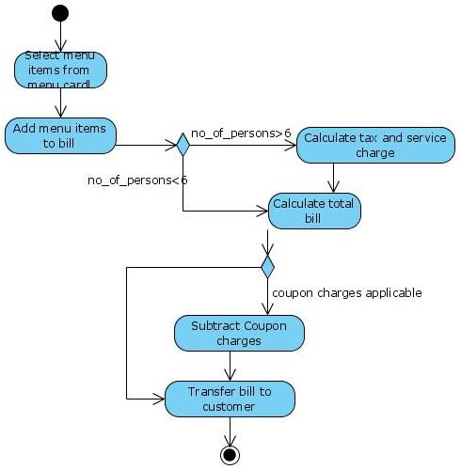

**Code**

from tkinter import *

import time

import numpy as np

from PIL import ImageTk, Image

import random

menu_data = np.genfromtxt('Menu.csv',delimiter = ',',skip_header=1)

menu = [ ]

for i in menu_data:

menu.append(int(i))

window = Tk()

window.geometry("1600x8000")

window.title("CAFE BILL MANAGEMENT")

ll = Label(window, text="----------------- BATCH 5 COFFEE HOUSE -----------------", font=("roman", 30))

ll.place(x=75, y=20)

ll.configure(bg="grey", fg="black")

lt = time.asctime(time.localtime(time.time()))

time_label = Label(window, font=('aria', 12,), text=lt, fg="black")

time_label.place(x=75, y=80)

def calculate():

if (e1.get() == ""):

m1 = 0

else:

m1 = e1.get()

if (e2.get() == ""):

m2 = 0

else:

m2 = e2.get()

if (e3.get() == ""):

m3 = 0

else:

m3 = e3.get()

if (e4.get() == ""):

m4 = 0

else:

m4 = e4.get()

if (e5.get() == ""):

m5 = 0

else:

m5 = e5.get()

if (e6.get() == ""):

m6 = 0

else:

m6 = e6.get()

if (e7.get() == ""):

m7 = 0

else:

m7 = e7.get()

if (e8.get() == ""):

m8 = 0

else:

m8 = e8.get()

if (e9.get() == ""):

m9 = 0

else:

m9 = e9.get()

if (e10.get() == ""):

m10 = 0

else:

m10 = e10.get()

if (e11.get() == ""):

m11 = 0

else:

m11 = e11.get()

if (e12.get() == ""):

m12 = 0

else:

m12 = e1.get()

cus_name = e13.get()

cus_num = e14.get()

total = (int(m1) * menu[0] + int(m2) * menu[1] + int(m3) * menu[2] + int(m4) * menu[3] + int(m5) * menu[4] + int(m6) * menu[5] + int(

m7) * menu[6] + int(m8) * menu[7] + int(m9) * menu[8] + int(m10) * menu[9] + int(m11) * menu[10] + int(m12) * menu[11])

#print(total)

e15.set(str(total))

return total

def Reset():

e1.set("")

e2.set("")

e3.set("")

e4.set("")

e5.set("")

e6.set("")

e7.set("")

e8.set("")

e9.set("")

e10.set("")

e11.set("")

e12.set("")

e13.set("")

e14.set("")

e15.set("")

#text.delete(1.0,END)

def bill_reciept():

total = calculate()

bill_win = Tk()

bill_win.geometry("900x700")

bill_win.title("BILL RECIEPT")

f = Frame(bill_win,bd = 10)

f.place(x=45, y=20, width=550, height=660)

f.configure(bg="mistyrose4")

bt = Label(f, text="BILL RECIEPT", font="arial 15 bold", bd=7).pack(fill=X)

text = Text(f,font = 'arial 15 bold')

text.pack(fill=BOTH)

def file_save():

with open("C:\\Users\\Nikkitha\\Documents\\MP\\Bill\\"+str(e13.get())+str(random.randint(100,300))+".txt",'a') as f:

f.write("===========BATCH 5 COFFEE SHOP===========")

f.write("\nCustomer Name :"+e13.get())

f.write("\nPhone no :"+e14.get())

f.write("\n-----------------------------------------------------------------------\n")

f.write('ITEMS\t\t QUANTITY \t RATE(1)\t COST')

f.write("\n-----------------------------------------------------------------------")

if (e1.get() == ""):

pass

else:

m1 = int(e1.get())

f.write("\nSingle\t\t "+str(m1)+"\t "+str(menu[0])+"\t "+str(m1*menu[0]))

if (e2.get() == ""):

pass

else:

m2 = int(e2.get())

f.write("\nDouble\t\t "+str(m2)+"\t "+str(menu[1])+"\t "+str(m2*menu[1]))

if (e3.get() == ""):

pass

else:

m3 = int(e3.get())

f.write("\nAmerican\t "+str(m3)+"\t "+str(menu[2])+"\t "+str(m3*menu[2]))

if (e4.get() == ""):

pass

else:

m4 = int(e4.get())

f.write("\nCappuccino\t "+str(m4)+"\t "+str(menu[3])+"\t "+str(m4*menu[3]))

if (e5.get() == ""):

pass

else:

m5 = int(e5.get())

f.write("\nLatte \t\t "+str(m5)+"\t "+str(menu[4])+"\t "+str(m5*menu[4]))

if (e6.get() == ""):

pass

else:

m6 = int(e6.get())

f.write("\nMacchaito\t "+str(m6)+"\t "+str(menu[5])+"\t "+str(m6*menu[5]))

if (e7.get() == ""):

pass

else:

m7 = int(e7.get())

f.write("\nMocha \t\t "+str(m7)+"\t "+str(menu[6])+"\t "+str(m7*menu[6]))

if (e8.get() == ""):

pass

else:

m8 = int(e8.get())

f.write("\nAdd Jelly\t "+str(m8)+"\t "+str(menu[7])+"\t "+str(m8*menu[7]))

if (e9.get() == ""):

pass

else:

m9 = int(e9.get())

f.write("\nAdd Flavor\t "+str(m9)+"\t "+str(menu[8])+"\t "+str(m9*menu[8]))

if (e10.get() == ""):

pass

else:

m10 = int(e10.get())

f.write("\nBlack Coffee\t "+str(m10)+"\t "+str(menu[9])+"\t "+str(m10*menu[9]))

if (e11.get() == ""):

pass

else:

m11 = int(e11.get())

f.write("\nIce Latte\t "+str(m11)+"\t "+str(menu[10])+"\t "+str(m11*menu[10]))

if (e12.get() == ""):

pass

else:

m12 = int(e12.get())

f.write("\nIce Cappucino\t "+str(m12)+"\t "+str(menu[11])+"\t "+str(m12*menu[11]))

total = calculate()

f.write("\n-----------------------------------------------------------------------")

f.write("\nTotal amount : "+str(total))

f.write("\nGST(6%) :"+str(total*0.06))

total = total +total*0.06

f.write("\nFinal Amount : "+str(total))

Save = Tk()

Save.geometry('400x400')

Save.title("SAVED")

Label(Save , text = "BILL IS SAVED!!",font = "arial 30 bold").place(x=50,y=150)

text.insert(END,"===========BATCH 5 COFFEE SHOP===========")

text.insert(END,"\nCustomer Name\t:"+e13.get())

text.insert(END,"\nPhone no\t :"+e14.get())

text.insert(END,"\n-----------------------------------------------------------------------\n")

text.insert(END,'ITEMS\t\t QUANTITY \t RATE(1)\t COST')

text.insert(END,"\n-----------------------------------------------------------------------")

if (e1.get() == ""):

pass

else:

m1 = int(e1.get())

text.insert(END,"\nSingle\t\t "+str(m1)+"\t "+str(menu[0])+"\t "+str(m1*menu[0]))

if (e2.get() == ""):

pass

else:

m2 = int(e2.get())

text.insert(END,"\nDouble\t\t "+str(m2)+"\t "+str(menu[1])+"\t "+str(m2*menu[1]))

if (e3.get() == ""):

pass

else:

m3 = int(e3.get())

text.insert(END,"\nAmerican\t\t "+str(m3)+"\t "+str(menu[2])+"\t "+str(m3*menu[2]))

if (e4.get() == ""):

pass

else:

m4 = int(e4.get())

text.insert(END,"\nCappuccino\t\t "+str(m4)+"\t "+str(menu[3])+"\t "+str(m4*menu[3]))

if (e5.get() == ""):

pass

else:

m5 = int(e5.get())

text.insert(END,"\nLatte \t\t "+str(m5)+"\t "+str(menu[4])+"\t "+str(m5*menu[4]))

if (e6.get() == ""):

pass

else:

m6 = int(e6.get())

text.insert(END,"\nMacchaito\t\t "+str(m6)+"\t "+str(menu[5])+"\t "+str(m6*menu[5]))

if (e7.get() == ""):

pass

else:

m7 = int(e7.get())

text.insert(END,"\nMocha \t\t "+str(m7)+"\t "+str(menu[6])+"\t "+str(m7*menu[6]))

if (e8.get() == ""):

pass

else:

m8 = int(e8.get())

text.insert(END,"\nAdd Jelly\t\t "+str(m8)+"\t "+str(menu[7])+"\t "+str(m8*menu[7]))

if (e9.get() == ""):

pass

else:

m9 = int(e9.get())

text.insert(END,"\nAdd Flavor\t\t "+str(m9)+"\t "+str(menu[8])+"\t "+str(m9*menu[8]))

if (e10.get() == ""):

pass

else:

m10 = int(e10.get())

text.insert(END,"\nBlack coffee\t\t "+str(m10)+"\t "+str(menu[9])+"\t "+str(m10*menu[9]))

if (e11.get() == ""):

pass

else:

m11 = int(e11.get())

text.insert(END,"\nIce Latte\t\t "+str(m11)+"\t "+str(menu[10])+"\t "+str(m11*menu[10]))

if (e12.get() == ""):

pass

else:

m12 = int(e12.get())

text.insert(END,"\nIce Cappucino\t\t "+str(m12)+"\t "+str(menu[11])+"\t "+str(m12*menu[11]))

def close():

bill_win.destroy()

text.insert(END,"\n-----------------------------------------------------------------------")

text.insert(END,"\nTotal Amount : "+str(total))

text.insert(END,"\nGST(6%) :"+str(total*0.06))

final = total +total*0.06

text.insert(END,"\nFinal Amount : "+str(final))

bn = Button(bill_win,text = "SAVE",font=('bold', 14), width=10, command=file_save)

bn.place(x=700,y=200)

bn.configure(fg="black", bg="grey")

bn1 = Button(bill_win,text = "QUIT",font = ('bold',14),width = 10,command = close)

bn1.place(x=700,y=400)

bn1.configure(fg="black",bg="grey")

e1 = StringVar()

e2 = StringVar()

e3 = StringVar()

e4 = StringVar()

e5 = StringVar()

e6 = StringVar()

e7 = StringVar()

e8 = StringVar()

e9 = StringVar()

e10 = StringVar()

e11 = StringVar()

e12 = StringVar()

e13 = StringVar()

e14 = StringVar()

e15 = StringVar()

f1 = Frame(window)

f1.place(x=1140, y=80, width=200, height=570)

f1.configure(bg="mistyrose4")

l0 = Label(window, text="MENU", font=("roman", 22))

l0.place(x=1190, y=90)

l0.configure(fg="black")

l01 = Label(window, text="HOT COFFEE", font=("roman", 16))

l01.place(x=1170, y=150)

l01.configure(bg="navajowhite4", fg="black")

l1 = Label(window, text="Single...........Rs."+str(menu[0]), font=("bold",13))

l1.place(x=1165, y=190)

l2 = Label(window, text="Double..........Rs."+str(menu[1]), font=("bold",13))

l2.place(x=1165, y=220)

l3 = Label(window, text="American......Rs."+str(menu[2]), font=("bold",13))

l3.place(x=1165, y=250)

l4 = Label(window, text="Cappuccino..Rs."+str(menu[3]), font=("bold",13))

l4.place(x=1165, y=280)

l5 = Label(window, text="Latte.............Rs."+str(menu[4]), font=("bold",13))

l5.place(x=1165, y=310)

l6 = Label(window, text="Macchiato.....Rs."+str(menu[5]), font=("bold",13))

l6.place(x=1165, y=340)

l02 = Label(window, text="ICE BLENDED", font=("roman", 16))

l02.place(x=1170, y=374)

l02.configure(bg="navajowhite4", fg="black")

l7 = Label(window, text="Mocha..........Rs."+str(menu[6]), font=("bold",13))

l7.place(x=1165, y=410)

l8 = Label(window, text="Add Jelly........Rs."+str(menu[7]), font=("bold",13))

l8.place(x=1165, y=440)

l9 = Label(window, text="Add flavor.......Rs."+str(menu[8]), font=("bold",13))

l9.place(x=1165, y=470)

l03 = Label(window, text="ICE COFFEE", font=("roman", 16))

l03.place(x=1170, y=503)

l03.configure(bg="navajowhite4", fg="black")

l10 = Label(window, text="Black Coffee..Rs."+str(menu[9]), font=("bold",13))

l10.place(x=1165, y=540)

l11 = Label(window, text="Lattee............Rs."+str(menu[10]), font=("bold",13))

l11.place(x=1165, y=570)

l12 = Label(window, text="Cappuccino...Rs."+str(menu[11]), font=("bold",13))

l12.place(x=1165, y=600)

c1 = Label(window,text="Customer Name :",font =("roman",12),bd=7)

c1.place(x=75 , y = 110)

c1.configure(bg="mistyrose4",fg="black")

tc1 = Entry(window,textvariable = e13,bd=10)

tc1.place(x=210,y=110)

c2 = Label(window,text="Phone No :",font =("roman",12),bd=7)

c2.place(x=400 , y = 110)

c2.configure(bg="mistyrose4",fg="black")

tc2 = Entry(window,textvariable = e14,bd=10)

tc2.place(x=490,y=110)

l001 = Label(window, text="Hot Coffee(Quantity ordered)", font=("roman", 14))

l001.place(x=715, y=90)

l001.configure(bg="mistyrose4", fg="black")

l13 = Label(window, text="Single", font=("bold", 14))

l13.place(x=715, y=130)

te1 = Entry(window, textvariable=e1)

te1.place(x=715, y=165)

l14 = Label(window, text="Double", font=("bold", 14))

l14.place(x=915, y=130)

te2 = Entry(window, textvariable=e2)

te2.place(x=915, y=165)

l15 = Label(window, text="American", font=("bold", 14))

l15.place(x=715, y=185)

te3 = Entry(window, textvariable=e3)

te3.place(x=715, y=215)

l16 = Label(window, text="cappuccino", font=("bold", 14))

l16.place(x=915, y=185)

te4 = Entry(window, textvariable=e4)

te4.place(x=915, y=215)

l17 = Label(window, text="Latte", font=("bold", 14))

l17.place(x=715, y=235)

te5 = Entry(window, textvariable=e5)

te5.place(x=715, y=265)

l18 = Label(window, text="Macchiato", font=("bold", 14))

l18.place(x=915, y=235)

te6 = Entry(window, textvariable=e6)

te6.place(x=915, y=265)

l002 = Label(window, text="Ice Blend(Quantity ordered)", font=("roman", 14))

l002.place(x=715, y=305)

l002.configure(bg="mistyrose4", fg="black")

l19 = Label(window, text="Mocha", font=("bold", 14))

l19.place(x=715, y=340)

te7 = Entry(window, textvariable=e7)

te7.place(x=715, y=375)

l20 = Label(window, text="Add Jelly", font=("bold", 14))

l20.place(x=915, y=340)

te8 = Entry(window, textvariable=e8)

te8.place(x=915, y=375)

l21 = Label(window, text="Add flavor", font=("bold", 14))

l21.place(x=715, y=395)

te9 = Entry(window, textvariable=e9)

te9.place(x=715, y=425)

l003 = Label(window, text="Ice Coffee(Quantity ordered)", font=("roman", 14))

l003.place(x=715, y=460)

l003.configure(bg="mistyrose4", fg="black")

l22 = Label(window, text="Black Coffe", font=("bold", 14))

l22.place(x=715, y=495)

te10 = Entry(window, textvariable=e10)

te10.place(x=715, y=530)

l23 = Label(window, text="Latte", font=("bold", 14))

l23.place(x=915, y=495)

te11 = Entry(window, textvariable=e11)

te11.place(x=915, y=530)

l24 = Label(window, text="Cappucino", font=("bold", 14))

l24.place(x=715, y=555)

te12 = Entry(window, textvariable=e12)

te12.place(x=715, y=590)

img = ImageTk.PhotoImage(Image.open("cof.jpg"))

pic_label = Label(window, image = img)

pic_label.place(x=95 , y = 180)

b = Button(window, text="GENERATE BILL", font=('bold', 14), width=15, command=bill_reciept)

b.place(x=715, y=680)

b.configure(fg="black", bg="grey")

r = Button(window, text="RESET", font=( 'bold',14), width=10, command=Reset)

r.place(x=915, y=680)

r.configure(fg="black", bg="grey")

final_amt = Label(window, font=('bold',18), text="TOTAL", bg="grey", fg="black")

final_amt.place(x=1100, y=682)

tot = Entry(window, font=('arial', 15, 'bold'), text=e15, width=6,bd=6)

tot.place(x=1190, y=680)

window. mainloop ()